

Data archive

Procedure

STATUS INFORMATION

Security classification: | Confidential |  | State: | Final
Current version number: | 1.0 | Date of first issue: |  | 05/05/2008
Prepared by: | Nourou Dine Issaka |  | Date: | 05/05/2008
Verified by: | Nicolas Macaire |  | Date: | 09/05/2008
Approved by: | Julien Andrieux |  | Date: | 12/05/2008
Document owner: | Fouzia Ziani
Copyright notice
This document may not be reproduced (even partially) or communicated to third parties without the written authorization of the company’s General Management.
DISTRIBUTION LIST
Name | Address | I/A/V
Julien Simon | julien.simon@digiplug.com | V/A
Julien Andrieux | julien.andrieux@digiplug.com | V/A
IT Operations Team |  | I/A
Nicolas Tavier | Nicolas.tavier@accenture.com | I
Morgan Ledu | Morgan.ledu@accenture.com | I
Moulay Younes Alaoui Rizq | moulay.y.alaoui-rizq@accenture.com | I
Nicolas Macaire | nicolas.macaire@accenture.com | I
Nourou Dine Issaka | nourou.dine.issaka@accenture.com | I
(I = for information, A = for action, V=for validation)
DOCUMENT CHANGE RECORD
Version | Date | Description | Affected sections
V0.1 to 0.3 | 19/05/2008 | Initialization | All
V1.0 | 02/06/08 | Final | All

IT Contact PEople
Function | Name
IT Lead | Julien Andrieux
IT Consultant | Moulay Younes Alaoui-Rizq
IT Consultant | Nicolas Macaire
IT Consultant | Nourou Dine Issaka

Table of content
1 Introduction 5
1.1 Definition and Purpose 5
1.2 Scope 5
1.3 Glossary 5
2 Archiving overview 6
2.1 Archived elements 6
2.1.1 Database 6
2.1.2 Log files 6
2.1.3 Configuration files 6
2.1.4 Application releases 6
2.2 Archiving infrastructure 7
2.3 Archiving schedule 7
2.4 Retention period 7
2.5 Archiving monitoring 7

Introduction

Definition and Purpose
Archiving is the process dealing with the removal of data from the production environment and its online storage to an external offline storage media for later retrieval and use.

During the lifecycle of business transactions, supporting data will be retained in an online setting. As they advance though the transaction lifecycle, data may be revised, deleted or corrected. Upon completion of the lifecycle the data can no longer be updated. It is at this point that the data, etc. may be removed from the online setting and archived to an offline storage facility. The data will remain in the archive facility for the time period required to fulfill business or legal requirements. At some point, the archived items may be disposed of.

Moreover, large quantities of data flow through a fully operational online system on a day-to-day basis. Despite significant improvements in system architecture and hardware capabilities, it is inevitable that certain database tables within the system will eventually grow to an unacceptably large size. This will have a direct impact on system performance, so in order to maintain acceptable performance levels data has to be removed from the system on a regular basis.

Archiving will assist in maintaining application performance by reducing the volume of inactive data in the operational storage systems. Archiving will result in:
- Helping storage capacity management, as archived data is moved to offline storage;
- Reducing database maintenance and administration effort and time;
- Improving response time;
- Stabilizing production environment;
- Allowing access to and reuse offline data;
- Making sure that all useful and appropriate information is archived along with the data.
In addition to improving technical operations, archiving will facilitate business operations and ensure that statutory data and document retention rules are observed. It also ensures that data can be accessed and re-used later.

Scope
This document describes the data archiving policy on the Digiplug/UMGI production platform.

Glossary
Isilon: The storage brand device used on UMGI platform.
Dump: Backup format used by Oracle Database to export database structure and its data.
Syslog: a standard protocol for forwarding log messages in an IP network.

Archiving overview

Archived elements
Many types of data run in the Digiplug/UMGI production platform. Not all of them need to be archived. In the archiving procedure, the following types of data are regarded:
- Database files;
- Log files;
- Configuration files;
- Application releases.

Database
Database archives are made of backed up files obtained by the Dump method. As explained in the “Data and database backup procedure”, these backup files have a determined retention time. Some of these backups will then be archived in compliance with the archiving schedule and kept in a separate offline storage infrastructure located at Digiplug’s head office.

Log files
Logs are recorded in all devices of infrastructure.

On the one hand, system logs are centralized in a Syslog server. As the server has a limited capacity, the logs are periodically sent to be stored in a dedicated repository on the Isilon storage.

On the other hand, applicative logs are files created by servers which store them in a centralized directory on the Isilon storage. Copies of those logs will be kept in archives.

Configuration files
To be able to reinstall or change a system component quickly in Digiplug production platform, configuration files must be kept and made available in the Isilon storage. Copies of those configuration files will also be stored in the offline storage in Digiplug head office.

Application releases
It is necessary and useful to keep traces of all the application releases that have been used on the production platform. Therefore, copies of releases will be saved as archives.

Archiving infrastructure
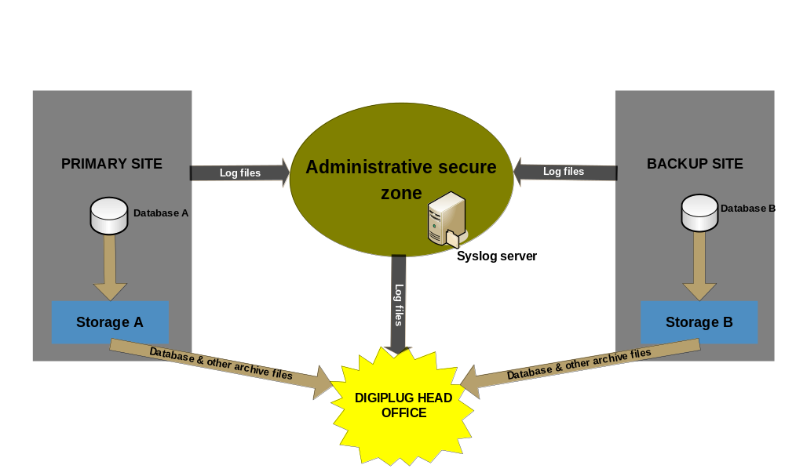

Image 1: Circuit of archived files

The picture above shows the path followed by data and log files to be archived. The production platform is configured to make this automatic.

Archiving schedule
As mentioned before, archives are backup files stored in the Isilon storage. A schedule will be defined to determine which backup files will be kept as archives. For example, a schedule can be defined as follows: every six months, data backup files are sent to Digiplug centralized archive storage (head office), and log files are archived every month.

Retention period
Digiplug manages its centralized archive storage capacity to enable archive files to be kept as long as needed.
The retention time for archive files is compliant with the Service Level Agreement (SLA) and with the legal period.

Archiving monitoring
Monitoring must be implemented to ensure that the archiving has been successfully executed.
The “monitoring management procedure “covers this part.

